Introduction to Network types
A computer network is a group of computers linked to each other that enables the computer to communicate with another computer and share their resources, data, and applications. Due to the varying communication requirements, geographical scopes and functionalities the need of different types of computer network arises.
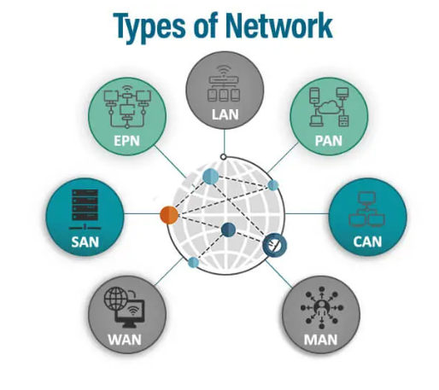

Based on the different requirements, there are mainly four types of computer network
- LAN(Local Area Network)
- WAN (Wide Area Network)
- MAN (Area Network)
- PAN (Personal Area Network)
Some other types of computer Network are:
- CAN (Campus Area Network)
- SAN (Storage Area Network)
- EPN (Enterprise Area Network)
- VPN (Virtual Private Network)

Types of Network
LAN
A Local Area Network (LAN) is a computer network that connects devices within a limited geographical area, such as a home, office, or school. It allows devices to share resources like files, printers, and internet connections, often using Ethernet or Wi-Fi technology. LAN is commonly used for Office environments for team collaboration, Educational institutions for resource sharing, Homes for connecting multiple devices like PCs, smart TVs, and printers.
Features:
- Limited Range: Typically covers a small area like a building or a campus.
- High Speed: Offers high data transfer rates, usually ranging from 100 Mbps to 10 Gbps.
- Resource Sharing: Enables sharing of hardware (e.g., printers) and software (e.g., applications).
- Centralized Management: Often controlled by a central server for security and administration.
- Low Cost: Relatively inexpensive to set up and maintain compared to larger networks.
- Private Network: Operates in a secure and controlled environment, not publicly accessible.
- Flexible Topologies: Supports various network layouts like star, bus, or ring.
Some advantages of LAN
- Resource Sharing: Simplifies sharing of printers, files, and applications among connected devices.
- High Speed: Ensures fast data transfer within the network.
- Cost-Effective: Reduces hardware costs through shared resources.
- Centralized Data: Allows easy management and backup of data in a central location.
- Enhanced Security: Access is typically restricted to authorized users.
- Supports Collaboration: Enables multiple users to work on shared projects or documents.
- Scalability: Can be easily expanded by adding new devices to the network.
- Reliable: Offers stable and dependable connectivity within its range.
MAN
A Metropolitan Area Network (MAN) is a network that spans a city, large campus, or metropolitan area, connecting multiple Local Area Networks (LANs). It is larger than a LAN but smaller than a Wide Area Network (WAN) and typically uses high-speed technologies like fiber optics for interconnectivity. Some use cases for WAN are Connecting branches of businesses across a city, providing city-wide public Wi-Fi services, linking university campuses or hospital networks, supporting municipal services like traffic control and surveillance.
Some Features of MAN
- Moderate Range: Covers a geographic area such as a city or town (up to 50 kilometers).
- High Speed: Provides faster communication compared to WAN, often using fiber optics or microwave links.
- Interconnection of LANs: Bridges multiple LANs within a city or region.
- Supports Public and Private Use: Can be used by organizations, educational institutions, or city authorities.
- Cost-Effective: Cheaper than deploying WAN for city-level connectivity.
- Technologies Used: Often relies on Ethernet, Wi-Fi, or MPLS for networking.
- Scalable: Can be expanded to accommodate growing connectivity needs.
Some advantages of LAN are:
- Broad Coverage: Connects multiple LANs over a wide area, facilitating communication across locations.
- High-Speed Data Transfer: Supports rapid sharing of data, ideal for video conferencing and large file transfers.
- Cost Savings: Reduces the need for separate connections by integrating LANs.
- Reliable Communication: Offers stable connections for urban or regional users.
- Resource Sharing: Enables shared access to internet services, data centers, and other resources across locations.
- Supports Smart City Applications: Powers initiatives like city-wide Wi-Fi, surveillance systems, and IoT infrastructure.
- Centralized Management: Allows efficient control and monitoring of the network.
WAN
A Wide Area Network (WAN) is a computer network that spans a large geographical area, connecting multiple smaller networks like LANs or MANs. It is used for communication across cities, countries, or even continents, often relying on technologies like leased lines, satellites, or the Internet. WAN is commonly used for Connecting multinational corporate offices, Supporting global e-commerce platforms, Powering cloud services and online applications, Enabling government and defense communication networks.

Some Features of WAN are:
- Large Coverage: Extends over vast areas, such as countries or continents.
- Interconnection of Networks: Connects smaller networks (e.g., LANs, MANs) to create a unified system.
- Variety of Communication Media: Utilizes satellites, optical fibers, or telephone lines.
- Lower Speed Compared to LAN: Speeds may vary depending on distance and technology.
- Decentralized Infrastructure: Operates across multiple regions and often involves third-party service providers.
- Costly Setup: Requires significant investment for infrastructure like leased lines or satellites.
- Global Connectivity: Enables communication and data sharing worldwide.
- Error-Prone: Due to longer distances, it is more susceptible to delays, packet loss, or security threats.
Some Benefits of WAN are:
- Global Communication: Facilitates connectivity between users and organizations across the world.
- Resource Sharing: Enables centralized access to data, software, and servers from remote locations.
- Supports Business Expansion: Helps organizations connect their geographically dispersed branches.
- Facilitates Collaboration: Allows teams from different regions to work together in real-time.
- Reliable Connectivity: Service providers ensure stable and uninterrupted communication.
- Supports Remote Work: Enables employees to securely access resources from anywhere.
- Scalability: Easily expandable to add new regions or users.
- Backbone of the Internet: WAN technologies power the global Internet infrastructure.

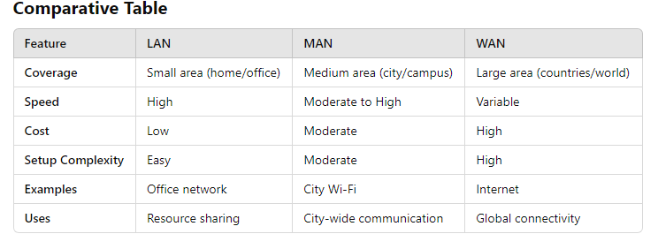

Topology
The configuration, or topology, of a network is key to determining its performance. Network topology is the way a network is arranged, including the physical or logical description of how links and nodes are set up to relate to each other.
There are numerous ways a network can be arranged, all with different pros and cons, and some are more useful in certain circumstances than others.
Think of your network as a city, and the topology as the road map.
There are two approaches to network topology: physical and logical. Physical network topology, as the name suggests, refers to the physical connections and interconnections between nodes and the network—the wires, cables, and so forth. Logical network topology is a little more abstract and strategic, referring to the conceptual understanding of how and why the network is arranged the way it is, and how data moves through it.
Physical – The physical network topology refers to the actual connections (wires, cables, etc.) of how the network is arranged. Setup, maintenance, and provisioning tasks require insight into the physical network.
Logical – The logical network topology is a higher-level idea of how the network is set up, including which nodes connect to each other and in which ways, as well as how data is transmitted through the network. Logical network topology includes any virtual and cloud resources.

Common types of Network Topology
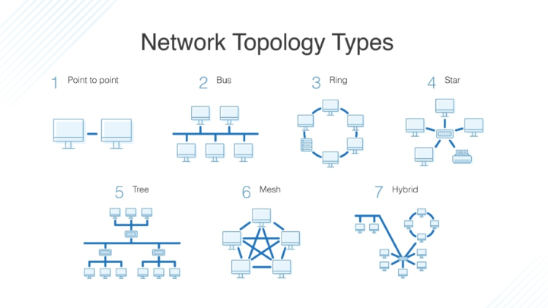

Bus Topology
A bus topology orients all the devices on a network along a single cable running in a single direction from one end of the network to the other—which is why it’s sometimes called a “line topology” or “backbone topology.” Data flow on the network also follows the route of the cable, moving in one direction.
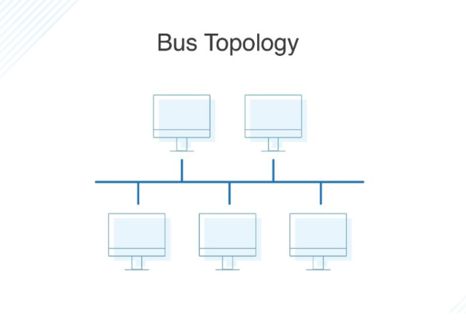

Advantages
Bus topologies are a good, cost-effective choice for smaller networks because the layout is simple, allowing all devices to be connected via a single coaxial or RJ45 cable. If needed, more nodes can be easily added to the network by joining additional cables.
- Cost effective
- Simplicity
- Ease of Expansion
- Ideal for small Networks
Disadvantages
Bus topologies use a single cable to transmit data, they’re somewhat vulnerable. If the cable experiences a failure, the whole network goes down, which can be time-consuming and expensive to restore, which can be less of an issue with smaller networks.
Bus topologies are best suited for small networks because there’s only so much bandwidth, and every additional node will slow transmission speeds. Furthermore, data is “half-duplex,” which means it can’t be sent in two opposite directions at the same time, so this layout is not the ideal choice for networks with huge amounts of traffic.
- Limited Scalability
- Reliability Issue
- Data Collision
- Low Security
Ring Topology
Ring topology is where nodes are arranged in a circle (or ring). The data can travel through the ring network in either one direction or both directions, with each device having exactly two neighbors.
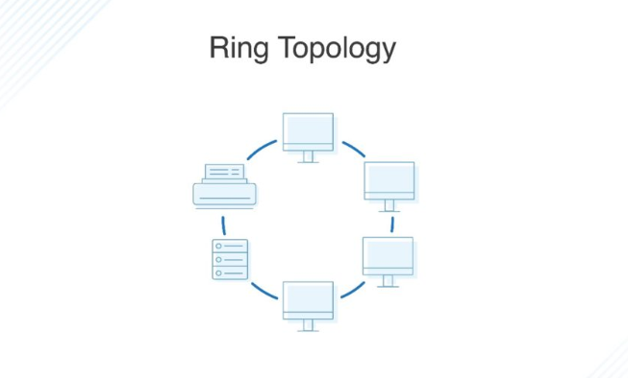

Advantages
- Efficient Data Transfer: Data packets travel in a single or predictable path, which minimizes collision risks. This is especially efficient in handling heavy traffic compared to bus topology.
- Easy to Diagnose Issues: Faults in the network are easier to pinpoint since every device checks data as it passes through.
- Equal Access to Resources: Each device in the network gets an equal opportunity to transmit data due to the token-passing method (used in Token Ring networks).
- Scalability: Adding devices to the network does not disrupt ongoing communication, as long as proper protocol is maintained.
Disadvantages
- Dependency on Each Node: If a single node fails or a connection breaks, the entire network may be disrupted unless redundancy (dual rings) is implemented.
- High Latency in Large Networks: Data must pass through intermediate devices, which increases latency in large networks.
- Maintenance Complexity: Troubleshooting and reconfiguration can be time-consuming, particularly if the network lacks a bypass mechanism for faulty nodes.
- Hardware Costs: Requires more cabling and connectors compared to bus topology, leading to higher initial costs.
What Is Dual-Ring Topology?
A network with ring topology is half-duplex, meaning data can only move in one direction at a time. Ring topologies can be made full-duplex by adding a second connection between network nodes, creating a dual ring topology.
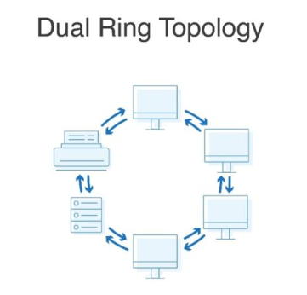

Star Topology
A star topology, the most common network topology, is laid out so every node in the network is directly connected to one central hub via coaxial, twisted-pair, or fiber-optic cable. Acting as a server, this central node manages data transmission—as information sent from any node on the network has to pass through the central one to reach its destination—and functions as a repeater, which helps prevent data loss.
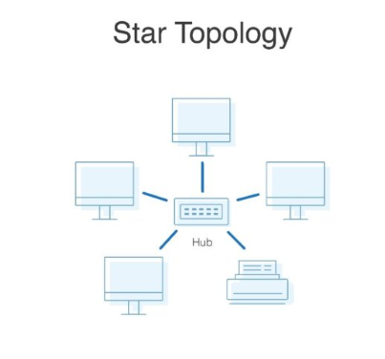

Advantages
Star topologies are common since they allow you to conveniently manage your entire network from a single location. Because each of the nodes is independently connected to the central hub, should one go down, the rest of the network will continue functioning unaffected, making the star topology a stable and secure network layout.
- Easy to Install and Manage: Simple to set up and maintain as each device has a direct connection to the central hub.
- Fault Isolation: Easy to identify and isolate issues since a single device failure doesn’t affect the rest of the network.
- Scalability: Adding new devices is straightforward without disrupting existing network operations.
- Efficient Performance: Traffic collisions are minimized due to the dedicated communication lines between devices and the central hub.
- Robustness: The network remains operational as long as the central hub is functional, even if individual devices fail.
Disadvantage
- Single Point of Failure: If the central hub or switch fails, the entire network becomes inoperable.
- Dependency on Hub Performance: Network performance heavily depends on the capability and quality of the central hub or switch.
Mesh Topology
A mesh topology is an intricate and elaborate structure of point-to-point connections where the nodes are interconnected. Mesh networks can be full or partial mesh. Partial mesh topologies are mostly interconnected, with a few nodes with only two or three connections, while full-mesh topologies are-fully interconnected.
The web-like structure of mesh topologies offers two different methods of data transmission: routing and flooding. When data is routed, the nodes use logic to determine the shortest distance from the source to destination, and when data is flooded, the information is sent to all nodes within the network without the need for routing logic.
Advantages
Mesh topologies are reliable and stable, and the complex degree of interconnectivity between nodes makes the network resistant to failure. For instance, no single device going down can bring the network offline.
Disadvantage
Mesh topologies are incredibly labor-intensive. Each interconnection between nodes requires a cable and configuration once deployed, so it can also be time-consuming to set up. As with other topology structures, the cost of cabling adds up fast, and to say mesh networks require a lot of cabling is an understatement.
Hybrid Topology
Hybrid topologies combine two or more different topology structures—the tree topology is a good example, integrating the bus and star layouts. Hybrid structures are most commonly found in larger companies where individual departments have personalized network topologies adapted to suit their needs and network usage.
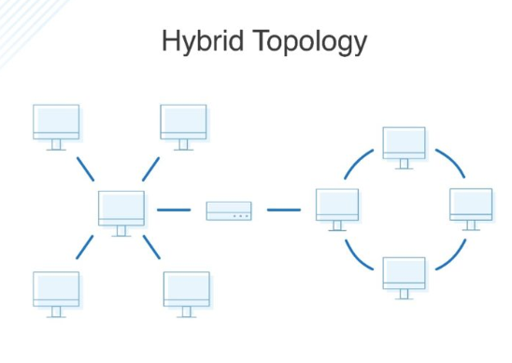

Advantages
The main advantage of hybrid structures is the degree of flexibility they provide, as there are few limitations on the network structure itself that a hybrid setup can’t accommodate.
Disadvantages
However, each type of network topology comes with its own disadvantages, and as a network grows in complexity, so too does the experience and know-how required on the part of the admins to keep everything functioning optimally. There’s also the monetary cost to consider when creating a hybrid network topology.

